vrClinicals for Nursing

Facilitator Guide

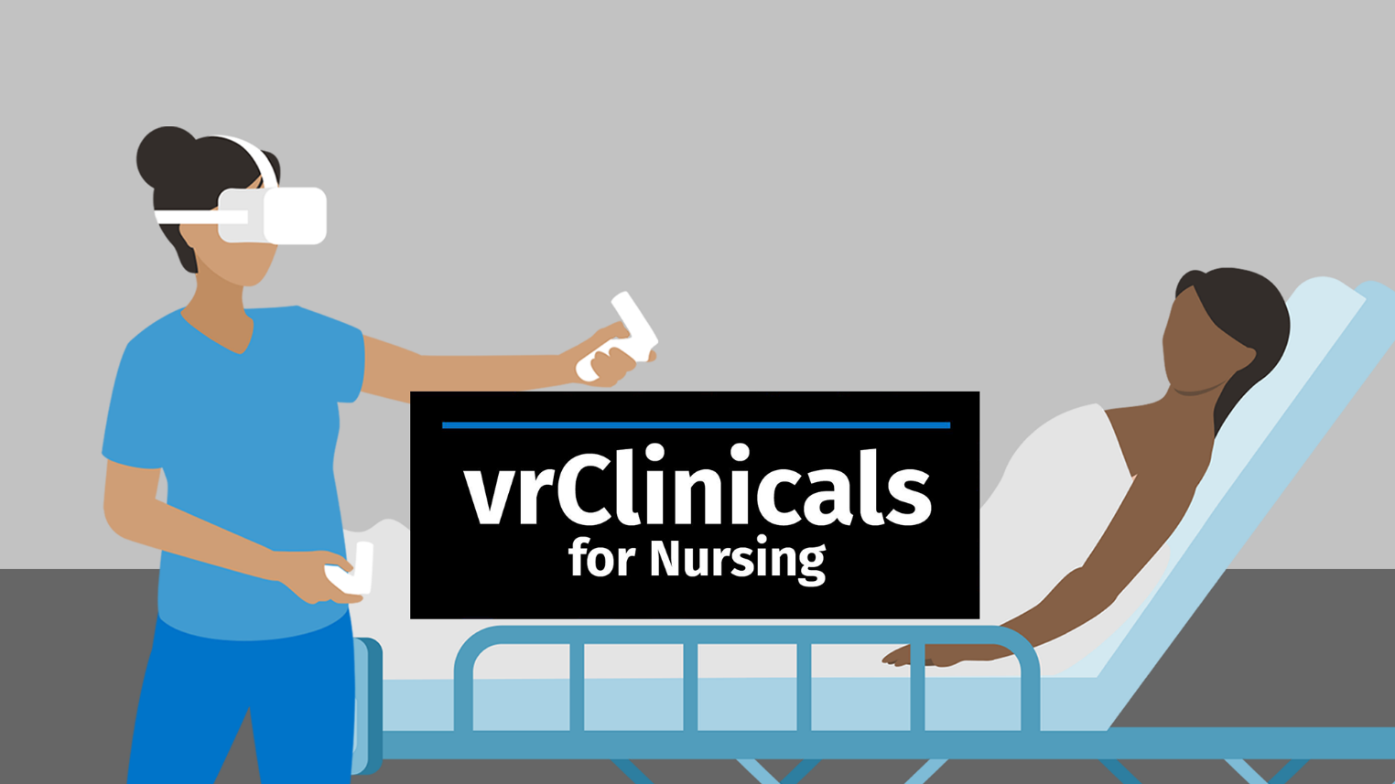

Developed by the National League for Nursing, Wolters Kluwer, and Laerdal Medical
Table of Contents
Purpose of the Facilitator Guide 3
Introduction to vrClincals for Nursing 3
A Virtual Teaching Solution for Nursing Practice Excellence 3
Multi-Patient, Leveled & Unfolding Scenarios 3
The Learner Experience: Overview 4
Build on Standards of Best Practice 5
Using vrClinicals for Nursing 6
Planning – Beginning with the end in mind 6
Preparing for the Learner Experience 16
Exploring the Learner Experience 19
Feedback and Evaluation 21
Teaching Strategies and Use Cases 24
On-Campus Clinicals 24
Alternative Teaching Strategies: Utilization in Classroom Teaching 26
Resources and References 26
Resources 26
References 27

Purpose of the Facilitator Guide
This guide provides an overview of vrClinicals for Nursing and gives guidance and strategies for using vrClinicals in programs across all types of nursing education. The purpose of the Facilitator Guide is to introduce the facilitator to the structure and processes for facilitating vrClinicals. It also provides faculty with ideas on how to integrate vrClinicals into existing curricula and offers ways to develop and/or enhance current teaching strategies.

Introduction to vrClincals for Nursing

A Virtual Teaching Solution for Nursing Practice Excellence
vrClinicals for Nursing is a robust teaching solution that promotes opportunities for learners to practice clinical knowledge, clinical reasoning, management of responsibilities, and skills in prioritizing care among multiple acute care patients in an immersive environment that includes the distractions and complexity of the real-world clinical setting. This novel approach to the acquisition of prioritization skills focuses on what the learner can do, their outcomes, and the promotion of competence through frequent feedback with both facilitated and formative self-assessment across a continuum of learning.

Clinical judgment – or nursing decision-making – is a core skill that is central to a nurse’s professional and clinical practice. Clinical reasoning – the cognitive precursor to clinical judgment – requires that nurses apply relevant and nuanced clinical knowledge to evolving patient care situations. While the acuity and complexity in which clinical reasoning is applied to patient care vary, the core ability and iterative process of making clinical decisions is a key requisite to providing quality care in every patient care encounter.

The National Council State Boards of Nursing (NCSBN) published new NextGen NCLEX exam item formats that aim to evaluate learners’ clinical judgment better. The Clinical Judgment Measurement Model (CJMM) provides a framework that outlines the steps of clinical judgment and identifies the context in which “thinking like a nurse” occurs. Nurse educators are challenged to use experiential teaching strategies that give learners opportunities to practice their clinical judgment skills in preparation for practice in complex healthcare settings.

Multi-Patient, Leveled & Unfolding Scenarios
vrClinicals for Nursing includes 3 submodules: Beginner, Intermediate, and Advanced, with patients of increasing complexity. The submodules are leveled so they can be used across the entire curriculum.

Each submodule includes a 2-, 3- and 4-patient experience, which again includes a 2-part unfolding scenario, adding up to a total of 18 medical-surgical multi-patient scenarios. Within each module, the 2-, 3-, and 4-patient scenarios feature the same patients, adding one new patient in the 3-patient scenario and one additional patient in the 4-patient scenario. Table 1 provides an overview of the structure.

When scenarios from the same submodule are used with an increasing number of patients, the learners will gradually be more challenged without the experience becoming overwhelming because one additional patient will be new each time. This allows learners to develop their skills in prioritizing care for multiple patients in an increasingly busy environment. Alternatively, scenarios from different submodules can be used to gradually increase the complexity of the patients.

 |  | Increasing number of patients
 |  | 2-patient | 3-patient | 4-patient
Increasing complexity of patients | Beginner  Patients with one main medical condition. Predictable progression with interruptions that are typical for patients in a med-surg unit. | Part 1  Day 1, 0730  Joan Biagini + Habib Abdallah | Part 1  Day 1, 0730  + Chales Donnaly | Part 1  Day 1, 0730  +Ishaan Kahn
 |  | Part 2  Same day, 1300  Joan Biagini + Habib Abdallah | Part 2  Same day,1300  + Chales Donnaly | Part 2  Same day,1300  +Ishaan Kahn
 | Intermediate  Patients with a primary medical condition and some with known comorbidities. Scenario progression with typical postoperative complications. | Part 1  Day 1, 0730  Brandon Williams + Molly Xi | Part 1  Day 1, 0730  + Deborah Enriquez | Part 1  Day 1, 0730  + George Romansky
 |  | Part 2  Same day, 1000  Brandon Williams + Molly Xi | Part 2  Same day,1000  + Deborah Enriquez | Part 2  Same day,1000  + George Romansky
 | Advanced  Patients with a primary medical condition and some with known comorbidities. Scenario progression with unexpected complications requiring immediate attention. | Part 1  Day 1, 1730  Quinn North + Marie O’Connor | Part 1  Day 1, 1730  + Peter Moyo | Part 1  Day 1, 1730  + Isa Mendoza
 |  | Part 2  Day 2, 0730  Quinn North + Marie O’Connor | Part 2  Day 2, 0730  + Peter Moyo | Part 2  Day 2, 0730  + Isa Mendoza
Table 1 Overview of the 18 vrClinicals for Nursing Medical-Surgical unfolding scenarios and how they increase in number of patients and complexity of the patients.

The Learner Experience: Overview
As a facilitator, it's essential to understand the flow of the vrClinicals for Nursing experience, which includes simulation in VR or on a screen. Here's a general overview:
- Pre-brief: vrClinicals starts with a synchronous pre-brief, in which you, as the facilitator, prepare the learners for the simulation experience. There is also an individual pre-briefing component in the learner flow on thePoint.
- Prioritization: Before entering the simulation, the learner gets an SBAR report on the patients and can review the electronic health records (EHRs). The learner will develop a plan of care and prioritize the order in which they see their patients. The prioritization exercise is done on a computer.
- Simulation: Entering the simulation, the learner is expected to implement care for patients as initially planned, but they will also be expected to respond to unpredictable situations and acute changes, creating the need to reprioritize patients and postpone planned actions. The simulation is done in VR. Alternatively, it is also possible to complete the simulation on a computer using the alternative screen-based app. However, VR is recommended for the most immersive experience.
- Reflection: Upon completing the simulation, the learner returns to their computer to complete a set of reflection exercises and receive feedback on their performance.
- Debrief: After completing a standalone or unfolding scenario, the learner participates in a group debrief with other learners, guided by you as the facilitator.

Build on Standards of Best Practice
The vrClinicals for Nursing experience is designed to support you, as a facilitator, in following the principles of The Healthcare Simulation Standards of Best Practice™. Table 2 gives an overview of how the standards are integrated into the vrClinicals process. For more information on the standards of best practice, visit Healthcare Simulation Standards of Best Practice® (inacsl.org)

HSSOBP ™ Standard | Integration into vrClinicals for Nursing
Pre-briefing | vrClinicals includes a two-step pre-briefing: synchronous pre-brief with the facilitator and the learner’s individual pre-briefing activities in the learner flow accessed through Wolters Kluwer’s thePoint.
Simulation design | Review vrClinicals simulation design under Exploring the Learner Experience.
Facilitation | vrClinicals is designed with recommended synchronous instructor-led pre-briefing and an end-of-simulation synchronous debriefing. The simulation part of vrClinicals is designed to be learner-led.
The debriefing process | The vrClinicals experience is designed to include a synchronous debriefing with an instructor. The provided scenario-specific debriefing guides aim to support instructor's facilitation of the debriefing. The guides are accessible through Wolters Kluwer’s thePoint. Through the learner flow on thePoint, learners can review recommendations for preparing their participation in a synchronous debriefing.
Operations | Guides are provided in thePoint (under vrClinicals resources) to support educators in setting up equipment (headset) and maintaining an updated app. In addition, tutorials are available to give an introduction on how to use the apps. Familiarity with the technical operations of vrClinicals promotes ease of use and therefore increased learner engagement.
Outcomes and objectives | Review vrClinicals learning outcomes under Leveled Learning Outcomes.
Professional integrity | vrClinicals provides a thoughtful, evidence-based structure and process that guides the learner through the learning experience. The experience includes two of the most important aspects that support professional integrity – pre-briefing and debriefing. Both instructor-led and learner-led pre-briefing and debriefing are designed within vrClinicals to create a psychological safe environment for learning, promoting learning engagement and commitment to the learning process and quality patient care.
Simulation-enhanced-IPE | vrClinicals focuses on creating an experience that puts the learner in the “shoes” of the nurse to promote real-time decision-making. Clinical decision-making requires an awareness and respect for interprofessional roles and responsibilities. During simulation, learners can delegate care and call other colleagues for assistance and coordination.
Evaluation of learning and performance | After each simulation, the learners go through self-led exercises including guided reflection questions, a review of performance scores, and guiding feedback.
Table 2 Overview of how vrClinicals for Nursing is built on The HealthCare Simulation Standards of Best PracticeTM (Onward and Upward: Introducing the Healthcare Simulation Standards of Best PracticeTM - Clinical Simulation In Nursing (nursingsimulation.org)).

Using vrClinicals for Nursing

Planning – Beginning with the end in mind
“Beginning with the end in mind’ serves as a reminder for educators to design and implement all learning experiences with a clear view of the desired outcome. There is a shift in nursing education toward using a competency-based education model that outlines a vision that creates a pathway toward competence and practice readiness” (National League for Nursing, 2023). While learning outcomes define the achievement of knowledge, skills, or abilities, a commitment to guiding learners toward meeting the outcomes requires a strategic, curricular, and programmatic shared mental model. Therefore, educators are encouraged to perform a needs assessment when integrating a curriculum solution, such as vrClinicals for Nursing. A needs assessment helps align the chosen vrClinicals level and experience to address identified gaps and learning needs that advance the learner toward achieving critical practice milestones.
To appreciate the learner's benefit and experience, it is important for nurse educators to briefly understand the structure that drives the learning experience and informs the evaluation data that supports the achievement of learning outcomes.

NCSBN NextGen CJMM and Learning Outcome Alignment
The concepts embedded in each learning outcome inform specific competencies that map directly to the National Council State Boards of Nursing (NCSBN) Clinical Judgment Measurement Model (CJMM). The CJMM is the foundation for how the NextGen NCLEX exam questions are designed. Clinical judgment is demonstrated in the CJMM by challenging the learner to think and reason through Layer 3 for a nursing issue within the context of care Layer 4 CJMM.

vrClinicals presents patient care scenarios that allow the learner to practice the skills of clinical reasoning that enhance their clinical judgment. The design of the patient care scenarios integrates with Layers 2 and 3 of the CJMM; the learners apply their knowledge and understanding and demonstrate their clinical reasoning skills in observable actions in the environment.

Overall Learning Outcomes
The overall learning outcomes are designed to support the development of clinical judgment and therefore align with the NCSBN’s Clinical Judgment Measurement Model. The alignment between vrClinicals learning outcomes and the CJMM provides educators and learners a shared mental model and lexicon from which to communicate learning goals, progress, learning needs, and a measurement model – while also building self-efficacy and academic fortitude in learners.

Three overarching learning outcomes drive the entire leveled experience:
- Integrate expanding clinical knowledge with clinical data to initiate the clinical reasoning process.
- Apply clinical reasoning skills to make clinical decisions for the care of individual patients.
- Manage responsibilities by prioritizing clinical decisions for the care of multiple patients with increasing complexity.
The integration of clinical knowledge is reflected in the CJMM Layer 4: Individual Factors. Clinical knowledge represents the prerequisite knowledge the learner brings to the learning encounter to apply to the discovery of clinical data presented by the patient care scenarios. The integration of clinical knowledge with clinical data initiates the clinical reasoning process.

The application of clinical reasoning to making patient care decisions begins with the clinical knowledge required to recognize relevant cues and continues through an iterative process leading to a patient care decision. The iterative and cognitive process of arriving at a clinical decision is reflected in Layer 3 of the CJMM.

Arriving at a clinical decision is not done in isolation but in the context of the acute care environment – with time pressure, task complexity, consequences, and risks. Making clinical decisions in the context of the environment is reflected in the CJMM Layer 4: Environmental Factors. The knowledge, skills, and abilities to manage responsibilities inform the ability to make clinical decisions in the complete context of the clinical setting – with interruptions, distractions, and evolving clinical data.

Graduate nurses need to gradually build their knowledge, skills, and abilities within each of the concepts over time, with deliberate practice (Ericsson, Krampe & Tesch-Romer, 1993), in multiple different contexts, and with expert feedback and guidance.

Leveled Learning Outcomes
In addition to the overarching outcomes, more detailed, leveled learning outcomes drive the learning at each level of vrClinicals for Nursing: Beginner, Intermediate, and Advanced. The learning outcomes at each level mark the competencies, as informed by the clinical reasoning process at Layer 3 in the CJMM, that learners strive to achieve as they move along the trajectory to practice. The vrClinicals leveled learning outcomes are structured as and reference the NCLEX description of the competencies listed below (2023 NCLEX-RN Test Plan | NCSBN):
- Recognize cues – Identify relevant and important information from different sources (e.g., medical history, vital signs).
- Analyze cues – Organize and connect the recognized cues to the client’s clinical presentation.
- Prioritize hypotheses – Evaluate and prioritize hypotheses (urgency, likelihood, risk, difficulty, time constraints, etc.).
- Generate solutions – Identify expected outcomes and use hypotheses to define a set of interventions for the expected outcomes.
- Take action – Implement the solution(s) that address the highest priority.
- Evaluate outcomes – Compare observed outcomes to expected outcomes.

Level | Beginner | Intermediate | Advanced
Characteristics for the level | Patients with one main medical condition. Predictable progression with interruptions that are typical for patients in a med-surg unit. | Patients with a primary medical condition and some with known comorbidities. Scenario progression with typical postoperative complications. | Patients with a primary medical condition and some with known comorbidities. Scenario progression with unexpected complications requiring immediate attention.
Recognize cues | Acknowledges unambiguous cues in SBAR and EHR. | Acknowledges cues in hand-off SBAR and clinical data. | Acknowledges clinical trends and ambiguous cues in hand-off SBAR or clinical data.
Analyze cues | Applies emerging clinical knowledge to process clinical data and information. | Applies foundational clinical knowledge to interpret trends in clinical data and information. | Applies integrated clinical knowledge to interpret clinical data and anticipate possible early signs and trends.
Prioritize hypotheses | Prioritizes the order in which to see the patients, adhering to provider orders and recommendations in the hand-off SBAR and EHR. | Prioritizes the order in which to see the patients based on interpreted cues and provider orders in the hand-off SBAR and clinical data. | Prioritizes the order in which to see the patients based on interpreted cues and required investigations (identified unambiguous cues or inconclusive data) and applies provider orders in hand-off SBAR and clinical data.
Generate solutions | - Applies provider orders in the care plan for the patients.  - Plans interventions and identify critical actions before entering the simulation. | - Applies identified tasks and provider orders in the care plan for the patient.  - Contemplates time sensitivity.  - Plans in-simulation follow-ups due to anticipated changes in patient condition requiring reprioritization. | - Applies plan of care and contemplates incoming data and requests for new provider orders.  - Contemplates increase in time sensitivity.  - Plans investigations and in-simulation follow-ups due to changes in patient condition requiring reprioritization.
Take action | - Implements plan of care with multiple treatment interventions.  - Acknowledges own limitations.  - Responds to loud and familiar interruptions.  - Reprioritizes the plan of care using emerging clinical data and patient care needs.  - Demonstrates effective time management in a healthcare setting with minimal interruptions. | - Implements the plan of care for patients with increasing complexity.  - Coordinates with the interprofessional team.  - Handles interruptions requiring follow-up.  - Responds to acute-onset needs using foundational clinical reasoning.  - Reprioritizes the plan of care, assessing the urgency of the interruptions.  - Demonstrates effective time management in a healthcare setting with a moderate level of interruptions. | - Implements the plan of care for patients with increasing complexity.  - Coordinates with the interprofessional team about acute changes in patient conditions.  - Handles interruptions requiring follow-up.  - Responds to acute-onset needs using integrated clinical reasoning.  - Reprioritizes the plan of care and differentiates between urgent issues and distractions.  - Delegates to manage tasks.  - Demonstrates effective time management in a healthcare setting with frequent interruptions.
Evaluate outcome | - Performs the correct evaluation measure to determine the effectiveness of actions | - Performs the correct evaluation to measure the expected outcomes, and identifies critical issues in the implemented care plan | - Performs the correct evaluation to measure the expected outcomes and identifies critical issues in the implemented care plan.
Table 3. Overview of the behaviors and actions related to each of the cognitive aspects of clinical decision-making that learners are expected to demonstrate at each of the three levels, Beginner, Intermediate, and Advanced.

Leveled Scenarios: Curriculum Integration
The vrClinicals for Nursing scenarios are designed to accommodate integration across nursing curricula. Prelicensure curricula and programs of study vary from program to program. However, most programs can be categorized into themes, as shown in Table 4.

Theme | Associated Courses
Foundational Nursing Care | Foundations in Nursing Concepts, Health Assessment, Pathophysiology, Basic Pharmacology
Clinical Nursing Care | Medical-Surgical Nursing Practice, Care of Populations: Community, Women and Children, Mental Health
Transition to Care | Practicum Experiences, Leadership, Advanced Medical-Surgical Nursing Practice
Table 4 Themes that can be identified in most nursing program structures and courses associated with each theme.
Table 5, Table 6, and Table 7 show at which nursing program and course level it is recommended to use each of the vrClinicals scenarios as well as the clinical knowledge that the learners should possess to have the most optimal and relevant simulation experience. In some cases, a course level is listed in parenthesis; this means that the scenario can also be used at that course level if the learners have prior experience with vrClinicals. Clinical knowledge that is needed for all scenarios in a level is listed as general requirements.
The recommendation takes the complexity of the patients, of prioritizing among them, and the overall time pressure into account. Moving between the levels of Beginner, Intermediate, and Advanced, the learners will gradually experience an increase in tasks, interprofessional collaboration, time pressure, and interruptions that require reprioritization.

Beginner Scenarios
Scenario | Co- or Prerequisite Courses | Recommended Co- and Prerequisite Knowledge
All Beginner Scenarios |  | General:  - Vital signs.  - Head-to-toe examination.  - Pain assessment.  - Oral medication administration.  - IV infusion management.  - Patient safety.  - Use of incentive spirometer.  - Therapeutic communication.  - Patient education.  - Delegation to unlicensed assistive personnel (optional at this level).
Two Patients  Part 1 and 2 | Foundational Nursing Care | Joan Biagini:  - Appendectomy.  - Postoperative care and assessment.  - Focused abdominal assessment.  - Discharge planning.  Habib Abdallah:  - Electrolyte imbalances, including dehydration, hypokalemia, and associated risks.  - Focused hydration status assessment, including intake & output and skin condition.  - Normal serum electrolyte values.  - Management of IV potassium infusion
Three Patients  Part 1 and 2 | Foundational Nursing Care (Clinical Nursing Care) | Joan Biagini:  - Appendectomy.  - Postoperative care and assessment.  - Focused abdominal assessment.  - Discharge planning.  Habib Abdallah:  - Electrolyte imbalances, including dehydration, hypokalemia, and associated risks.  - Focused hydration status assessment, including intake & output and skin condition.  - Normal serum electrolyte values.  - Management of IV potassium infusion.  Charles Donnally:  - Laparoscopic abdominal surgery.  - Perineal resection.  - Colostomy assessment and care, including awareness of potential complications.  - Postoperative care and assessment.  - Focused abdominal assessment.
Four Patients  Part 1 and 2 | Clinical Nursing Care (Transition to Care). | Joan Biagini:  - Appendectomy.  - Postoperative care and assessment.  - Focused abdominal assessment.  - Discharge planning.  Habib Abdallah:  - Electrolyte imbalances, including dehydration, hypokalemia, and associated risks.  - Focused hydration status assessment, including intake & output and skin condition.  - Normal serum electrolyte values.  - Management of IV potassium infusion.  Charles Donnally:  - Laparoscopic abdominal surgery.  - Perineal resection.  - Colostomy assessment and care, including awareness of potential complications.  - Postoperative care and assessment.  - Focused abdominal assessment.  Ishaan Khan:  - Aspiration pneumonia, including causes, symptoms, and treatment.  - Focused respiratory assessment.  - Administering and monitoring oxygen therapy.  - Principle of NPO, including its implications for hydration, nutrition, and medication administration.  - Hydration status assessment.  - Swallowing disorders, including swallowing studies.
Table 5 Recommended co- or prerequisite courses and knowledge needed for each of the beginner-level scenarios.
Intermediate Scenarios
Scenario | Co- or Prerequisite Courses | Recommended Co- and Prerequisite Knowledge
All Intermediate Scenarios |  | General:  - Vital signs.  - Head-to-toe examination.  - Pain assessment and management.  - Oral and IV medication administration.  - IV infusion management.  - Patient safety.  - Postoperative care and assessment.  - Prevention of postoperative complications, including thrombosis and respiratory issues.  - Signs and symptoms of possible postoperative complications.  - Use of incentive spirometer.  - Therapeutic communication.  - Patient education.  - Delegation to unlicensed assistive personnel and registered nurses (optional at this level)
Two Patients  Part 1 and 2 | Clinical Nursing Care  (Foundational Nursing Care) | Molly Xi:  - Uterine fibroids and laparoscopically assisted vaginal hysterectomy.  - Asthma and associated medication.  - Preoperative care (Part 1) and postoperative care (Part 2).  - Focused abdominal assessment.  - Focused respiratory assessment.  - Monitoring oxygen therapy.  Brandon Williams:  - Diverticulitis and laparoscopic hemicolectomy.  - Focused abdominal assessment.  - Hypertension and associated medication.  - Preparing for discharge.  - Signs and symptoms of deep vein thrombosis (DVT).  - Roles and responsibilities in responding to acute changes in condition (DVT in Part 1).  - Treatment for DVT (Part 2).
Three Patients  Part 1 and 2 | Clinical Nursing Care | Molly Xi:  - Uterine fibroids and laparoscopically assisted vaginal hysterectomy.  - Asthma and associated medication.  - Preoperative care (Part 1) and postoperative care (Part 2).  - Focused abdominal assessment.  - Focused respiratory assessment.  - Monitoring oxygen therapy.  Brandon Williams:  - Diverticulitis and laparoscopic hemicolectomy.  - Focused abdominal assessment.  - Hypertension and associated medication.  - Preparing for discharge.  - Signs and symptoms of deep vein thrombosis (DVT).  - Roles and responsibilities in responding to acute changes in condition (DVT, Part 1).  - Treatment for DVT (Part 2).  Deborah Enriquez:  - Tibia-fibula fracture and open reduction internal fixation procedure.  - Focused neurovascular assessment.  - Hypothyroidism and associated medication.  - Postoperative bloating: causes and treatments (Part 1).  - Signs and symptoms of dehydration (Part 2).  - Roles and responsibilities in responding to acute changes in condition (dehydration-induced hypotension, Part 2)
Four Patients  Part 1 and 2 | Clinical Nursing Care (Transition to Care). | Molly Xi:  - Uterine fibroids and laparoscopically assisted vaginal hysterectomy.  - Asthma and associated medication.  - Preoperative care (Part 1) and postoperative care (Part 2).  - Focused abdominal assessment.  - Focused respiratory assessment.  - Monitoring oxygen therapy.  Brandon Williams:  - Diverticulitis and laparoscopic hemicolectomy.  - Focused abdominal assessment.  - Hypertension and associated medication.  - Preparing for discharge.  - Signs and symptoms of deep vein thrombosis (DVT).  - Roles and responsibilities in responding to acute changes in condition (DVT, Part 1).  - Treatment for DVT (Part 2).  Deborah Enriquez:  - Tibia-fibula fracture and open reduction internal fixation procedure.  - Focused neurovascular assessment.  - Hypothyroidism and associated medication.  - Postoperative bloating: causes and treatments (Part 1).  - Signs and symptoms of dehydration (Part 2).  - Roles and responsibilities in responding to acute changes in condition (dehydration-induced hypotension, Part 2)  George Romansky:  - Bowel obstruction and laparotomy for left-sided colostomy.  - Managing PCA pump (patient-controlled analgesia).  - Focused abdominal assessment.  - Colostomy assessment and care, including awareness of potential complications.  - Signs and symptoms of wound infection (Part 2)  - Roles and responsibilities in responding to acute changes in condition (wound infection, Part 2)  - Principles of wound infection treatment (Part 2)
Table 6 Recommended co- or prerequisite courses and knowledge needed for each of the intermediate-level scenarios.

Advanced Scenarios
Scenarios | Co- or Prerequisite Courses | Recommended Co- and Prerequisite Knowledge
All Advanced Scenarios |  | General:  - Vital signs.  - Head-to-toe examination.  - Pain assessment and management.  - Oral and IV medication administration.  - IV infusion management.  - Patient safety.  - Lab values and diagnostic tests.  - Therapeutic communication.  - Patient education.  - Collaboration with other healthcare professionals.  - Coordinating and implementing changes in treatment plans.  - Delegation to registered nurses and unlicensed assistive personnel.
Two Patients  Part 1 and 2 | Transition to Care  (Clinical Nursing Care) | Quinn North:  - Puncture wounds and simple cellulitis.  - Wound infection: progression, assessment, care and treatment.  - Focused musculoskeletal and neurovascular assessment.  - Management of IV antibiotics including monitoring, risks, and potential complications.  - Signs and symptoms of reactions to IV antibiotics: differentiating between allergy and anaphylaxis (Part 1).  Marie O´Connor:  - Ulcerative colitis and associated medication.  - Postoperative care and assessment  - Focused abdominal assessment.  - Ileostomy assessment and care, including awareness of potential complications.  - Fluid and electrolytes management.  - Prevention, recognition, and management of postoperative complications.
Three Patients  Part 1 and 2 | Transition to Care | Quinn North:  - Puncture wounds and simple cellulitis.  - Wound infection: progression, assessment, care and treatment.  - Focused musculoskeletal and neurovascular assessment.  - Management of IV antibiotics including monitoring, risks, and potential complications.  - Signs and symptoms of reactions to IV antibiotics: differentiating between allergy and anaphylaxis (Part 1).  Marie O´Connor:  - Ulcerative colitis and associated medication.  - Postoperative care and assessment.  - Focused abdominal assessment.  - Ileostomy assessment and care, including awareness of potential complications.  - Fluid and electrolytes management.  - Prevention, recognition, and management of postoperative complications  Peter Moyo:  - Osteoarthritis and total knee replacement.  - Postoperative care and assessment.  - Focused musculoskeletal and neurovascular assessment.  - Prevention, recognition, and management of postoperative complications.  - Chronic stable angina: assessment, associated medication, and response to acute changes.
Four Patients  Part 1 and 2 | Transition to Care | Quinn North:  - Puncture wounds and simple cellulitis.  - Wound infection: progression, assessment, care and treatment.  - Focused musculoskeletal and neurovascular assessment.  - Management of IV antibiotics including monitoring, risks, and potential complications.  - Signs and symptoms of reactions to IV antibiotics: differentiating between allergy and anaphylaxis (Part 1).  Marie O´Connor:  - Ulcerative colitis and associated medication.  - Postoperative care and assessment.  - Focused abdominal assessment.  - Ileostomy assessment and care, including awareness of potential complications.  - Fluid and electrolytes management.  - Prevention, recognition, and management of postoperative complications  Peter Moyo:  - Osteoarthritis and total knee replacement.  - Postoperative care and assessment.  - Focused musculoskeletal and neurovascular assessment.  - Prevention, recognition, and management of postoperative complications.  - Chronic stable angina: assessment, associated medication, and response to acute changes.  Isa Mendoza:  - Urosepsis: causes, symptoms, and treatments.  - Focused assessment for urinary sepsis.  - Focused hydration status assessment, including intake & output and skin condition.  - Osteoporosis, hypertension, and atrial fibrillation and associated medication.  - Anticoagulant therapy: mechanism, indications, side effects, and associated risks.  - Post-fall management for patients on anticoagulant therapy (Part 2).
Table 7 Recommended co- or prerequisite courses and knowledge needed for each of the advanced scenarios.

Standalone vs. Unfolding Scenarios
All 18 vrClinicals scenarios include a full orientation to the patients and the situation, so they can be used as standalone scenarios or unfolding experiences that combine parts 1 and 2 of the scenario. This offers flexibility and accommodates various use situations and educational needs.

The single-part experience is ideal for introducing multi-patient prioritization, with the option to add patients gradually whereas the unfolding experience allows learners to continue caring for the same patients at different stages during their hospital stay, with feedback and rationales between the two parts to help adjust and improve their performance in the subsequent simulation.

To maximize the effectiveness of the simulation, it is recommended to select scenario(s) and patient cases aligned with nursing or medical subjects that are currently being taught or have been taught previously, considering when and where it is optimal to introduce the multi-patient perspective.

A standalone scenario is well-suited for a curriculum plan with shorter, recurring simulation activities. The unfolding scenario experience is designed for teaching activities such as preparation for clinical rotation, clinical replacement, and makeup activities. It is particularly relevant for full-day on-site clinicals or as part of a clinical Boot Camp. Review suggestions for implementation under On-Campus Clinicals.

Preparing for the Learner Experience
In the vrClinicals for Nursing learner flow, the facilitator ensures the learners are prepared before the experience. This includes both facilitator-led and learner-led pre-briefing components, which lay the foundation for an optimal experience and achievement of outcomes for the learners. Below are recommendations for how to prepare the learners for vrClinicals based on HSSBP for pre-briefing.

Preparation and Pre-briefing
The pre-brief consists of 2 components:
- Facilitator-led Preparation: Facilitators are expected to consider what learners need to know before arriving at the vrClinicals experience and what they need to know immediately before entering the learning encounter.
- Learner-led: When learners enter vrClinicals through thePoint, they will be guided through several pre-briefing details, including the learner flow, learning outcomes, expectations, learning activities, and the feedback format.

Facilitator-led preparation and pre-briefing of learners
Before learners arrive at the vrClinicals experience:
- Review recommended prerequisite knowledge for each level and scenario (part 1 and/or part 2) to ensure alignment with curricular delivery before the vrClinicals learning encounter. See the section Leveled Scenarios: Curriculum Integration for general requirement descriptions.
- Prepare the learners for the specific scenario part(s) and level. The expected learning outcomes and the complexity level of the simulation experiences increase gradually from Beginner, Intermediate, and Advanced scenarios. Discuss the gradual increase of time pressure and prepare the learners emotionally for experiences, where they will have to delegate and navigate situations where they may not be able to complete all the tasks they had planned.
- Learners will need to apply clinical knowledge while providing care in vrClinicals, so they need a foundation in nursing care concepts that align with each vrClinicals level (see the co- and prerequisite knowledge in Table 5, Table 6, and Table 7).
- Clinical knowledge refresher or reinforcement before the learning encounter provides cognitive priming (Unger & Sloutsky, 2022) for learners and promotes enhanced knowledge application and integration. Consider assigning a “prework” assignment ahead of the learning encounter.
Learners require explicit and planned learning experiences to understand, recognize clinical salience, and respond to multiple patient care situations that require nuanced and skilled decision-making (Jesse, 2019). Before learners arrive for the vrClinicals experience, plan activities and conversations with learners that promote awareness and guidance around how nurses make decisions when caring for multiple patients.
- Immediately before beginning the vrClinicals experience, prepare the physical space (technical requirements are on thePoint).
- The Healthcare Simulation Standards of Best Practice™: Pre-briefing (Healthcare Simulation Standards of Best PracticeTM Prebriefing: Preparation and Briefing - Clinical Simulation In Nursing (nursingsimulation.org) provides evidence-based guidance on learner preparation. Please review the standard for more details.
- The educator-led pre-brief on the day of the experience includes:
  - Co-creating a psychologically safe learning environment (Edmondson et al., 2016).
  - Logistics to include learner time commitment, breaks, and learner flow (see Learner Flow previously discussed).
  - Learner and educator roles and responsibilities during sessions together.

Time Requirements
When planning to use vrClinicals for nursing in your curriculum, it is important to consider the time requirements and facilitation recommendations. As outlined in Table 8, the approximate time requirements for using vrClinicals vary depending on the number of patients and whether you choose to use the optional unfolding scenarios. The table provides a detailed breakdown of the time requirements for each activity, including pre-work, pre-briefing, simulation, reflection, and debriefing.

Note, before learners are going to have their first real vrClinicals simulation session, it is recommended to also allow time for them to get familiar with the simulated environment, how to move around in it, and how to perform actions. This can be done for example by assigning the vrClinicals Tutorial to them and allowing them to try out the VR headset and controllers (or the screen-based app, if that’s what they will be using) during an intro session. The time for this introduction is not represented in the table, as it only needs to happen before the first vrClinicals session.

The simulation design of vrClinicals supports the theory of deliberate practice. The literature documents that simulation-based education combined with deliberate practice is effective in achieving specific clinical goals (McGaghie, lssenberg, Cohen, Barsuk, & Wayne, 2011). Thus, in curriculum integration planning, it is recommended that learners have time and opportunity to repeat the individual scenarios to achieve mastery.

Activity | Format | Faculty Role | Learner Role | Time  in mins  Two patients | Time  in mins  Three patients | Time  in mins  Four patients
Pre-Work | Asynchronous | Faculty preassigns curriculum content preparing the learner for the requirements of the Leveled Scenarios: Curriculum Integration | Complete prior to arrival. | N/A¹ | N/A¹ | N/A¹
Pre-brief | Synchronous/ in-lab immediately prior to simulation experience | Plan and lead pre-brief with learners. | Participate and ask questions. | N/A¹ | N/A¹ | N/A¹
Self-led  pre-brief | Learner flow via thePoint | Assign, provide time and resources for learners to log in | Review introduction to vrClinicals experience and the specific simulation | 15 | 15 | 15
Prioritization | Synchronous on screen/in-lab immediately prior to VR experience | Provide resources for learners to complete screen-based pre-simulation assignments | Review SBAR reports and EHRs, develop plan of care, and prioritize patients | 30 | 35 | 40
Simulation Part 1 | VR headset or screen-based app | Be available to help with technical issues and safety parameters. | Take care of patients in virtual hospital: Assess patients, intervene, and reprioritizes plan of care | 25 | 35 | 45
Suggested break |  |  |  | 10
Reflection | Screen-based | Provide resources for learners to complete screen-based assignments after completed simulation | Answer guided reflection questions and review scores and feedback | 20 | 25 | 30
Debrief² | Synchronous | Gather learners together to facilitate a synchronous debrief following the scenario specific debriefing guide | Participate in facilitator-guided debriefing with peer group. | 30 | 30 | 30
Approximate total time in hours (excl. suggested breaks): |  |  |  | 2:00 | 2:20 | 2:50
Optional unfolding experience
Prioritization | Synchronous on screen/ in-lab immediately prior to VR experience | Provide resources for learners to complete screen-based pre-simulation assignments | Review SBAR reports and EHRs, develop plan of care, and prioritize patients | 30 | 35 | 40
Simulation Part 2 | VR headset or screen-based app | Be available to help with technical issues and safety parameters. | Take care of patients in virtual hospital: Assess patients, intervene, and reprioritizes plan of care | 25 | 35 | 45
Suggested break |  |  |  | 10
Reflection | Screen-based | Provide resources for learners to complete screen-based assignments after completed simulation | Answer guided reflection questions and review scores and feedback | 20 | 25 | 30
Suggested break |  |  |  | 30
Debrief | Synchronous | Gather learners together to facilitate a synchronous debrief following the scenario specific debriefing guide | Participate in facilitator-guided debriefing with peer group. | 30 | 30 | 30
Approximate total time in hours (excl. suggested breaks): |  |  |  | 3:15  3:45³ | 3:55  4:25³ | 4:15  4:45³
Table 8 Approximate time requirements for using vrClinicals for nursing. Times are up to the educator’s discretion and best practice recommendations. ¹Times for prework and instructor-led pre-brief are not included in the estimates as it depends on what the facilitator deems necessary for each group of learners. ²Debriefing after 1st part is optional if using unfolding scenarios. ³Including debriefing after both rounds.

Exploring the Learner Experience

Introduction
vrClinicals for Nursing provides a rich learner experience that guides learners through a patient care experience that requires just-in-time nursing practice and generates reflection on practice. This section provides more details to describe the learner experience within the flow of vrClinicals: Prioritization, Simulation, and Reflection.

1. Prioritization
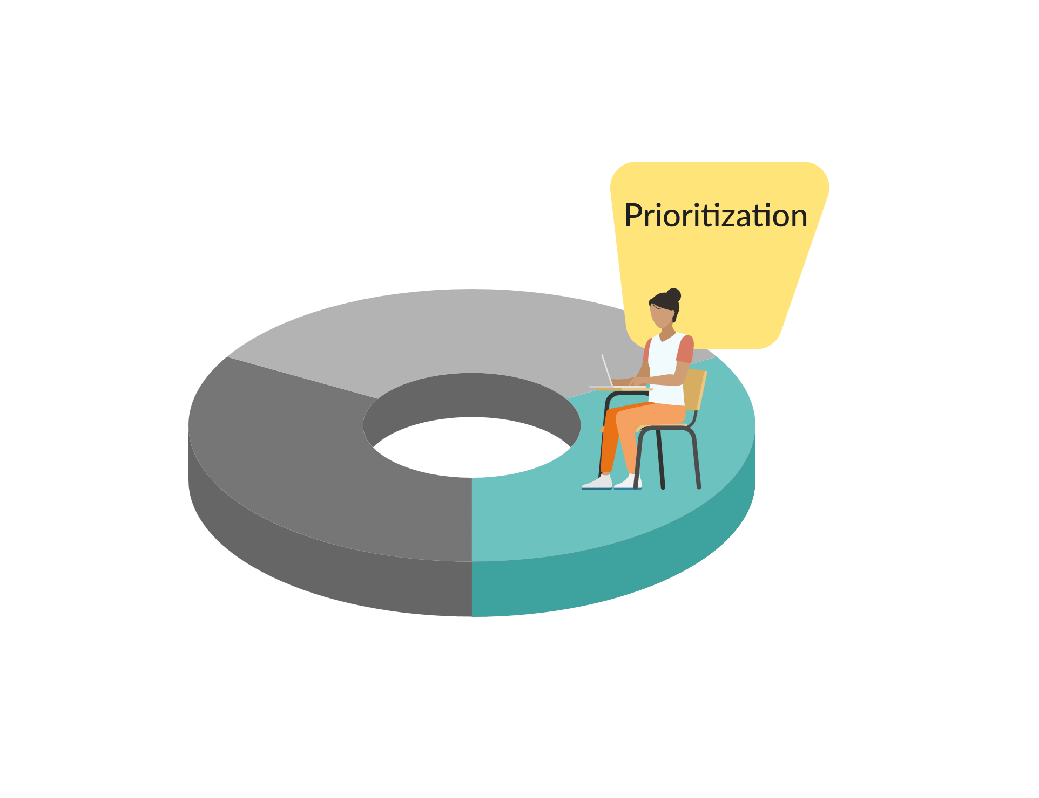
Before venturing into the simulation, the learner must plan and prioritize the care for their patients. During this phase, the learner reviews the SBAR reports and electronic health records on a computer and creates a plan of care by filling out the to-do list for each patient. Furthermore, the learner is asked to set a priority order for how they intend to see the patients and provide a rationale for that prioritization in writing.

2. Simulation
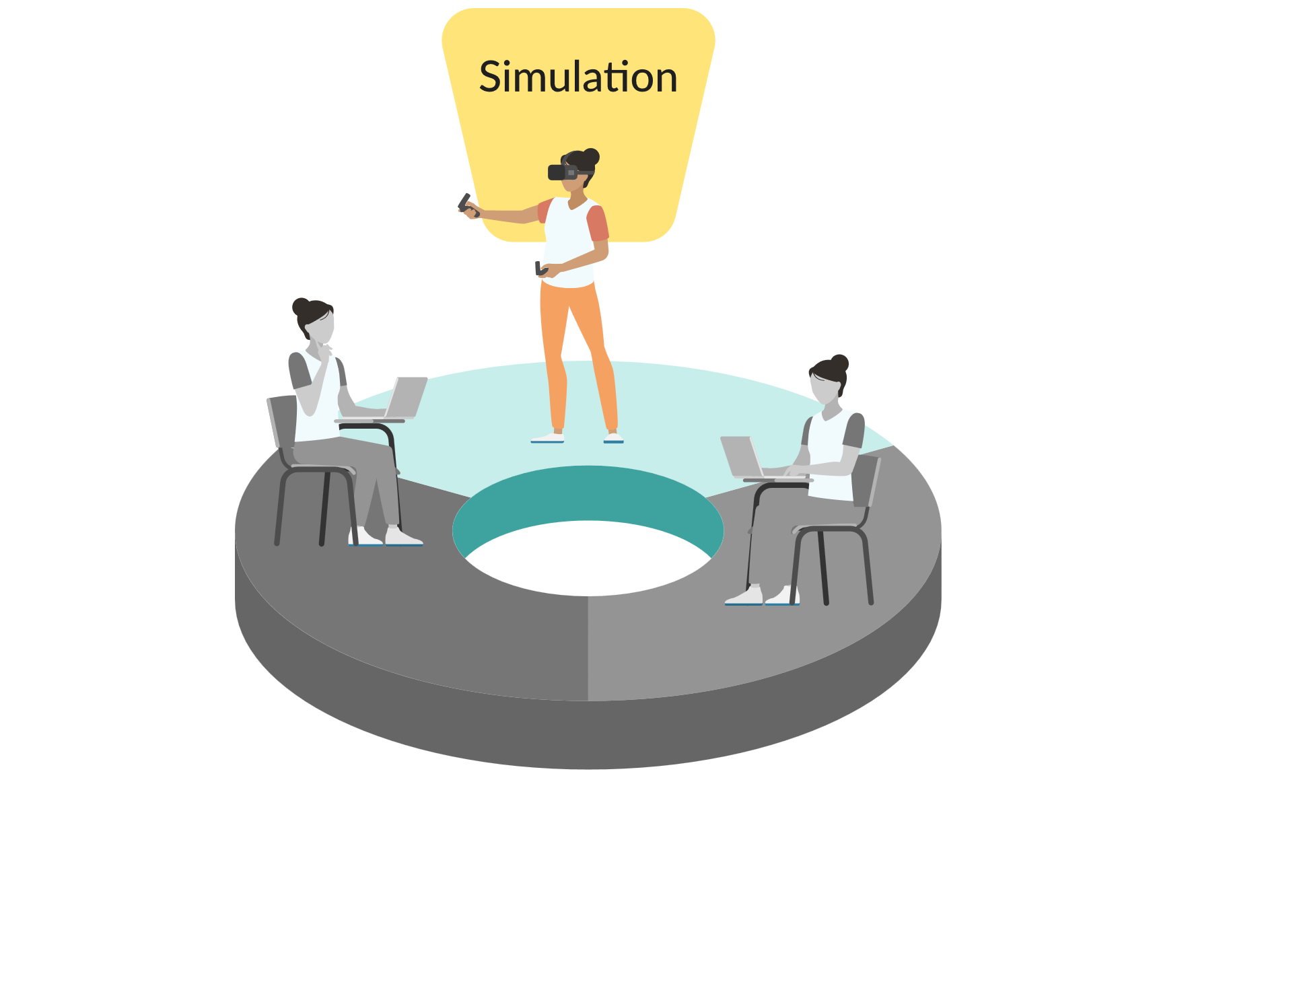
At the heart of the vrClinicals lies the simulation experience. In the VR-based version of the simulation, the learner will experience a unique sense of presence and agency in virtual reality. The learner will feel as if they are physically present in a busy hospital, being in full control of an avatar capable of moving around the hospital, picking up and using medical equipment, and interacting with both patients and colleagues on a medical-surgical unit. vrClinicals offers a screen-based simulation as an alternative to VR.

As the scenario starts, the learner will experience how it is to be a nurse, responding to real-life situations while caring for up to four patients simultaneously.

3. Reflection and the Six Rs
The reflection component of the vrClinical experience is crucial for meaningful learning and improved decision-making. It enables learners to analyze clinical data from patient care scenarios and understand their decision-making process. After each experience, learners are encouraged to reflect on their actions and articulate their reasoning behind specific decisions or interventions.

Guided reflection questions help learners connect separate pieces of clinical data they encountered during the simulation. This, combined with performance feedback, assists in reshaping their thought process for a better understanding of the scenario they experienced. Narrative pedagogy supports this reflective process.

Reflection activities in vrClinicals occur before, between, and after all simulation experiences. The focus shifts from reflection-in-action during simulation to reflection on-action thinking in an exercise in front of a computer (Schön, 1991)

The Six Rs
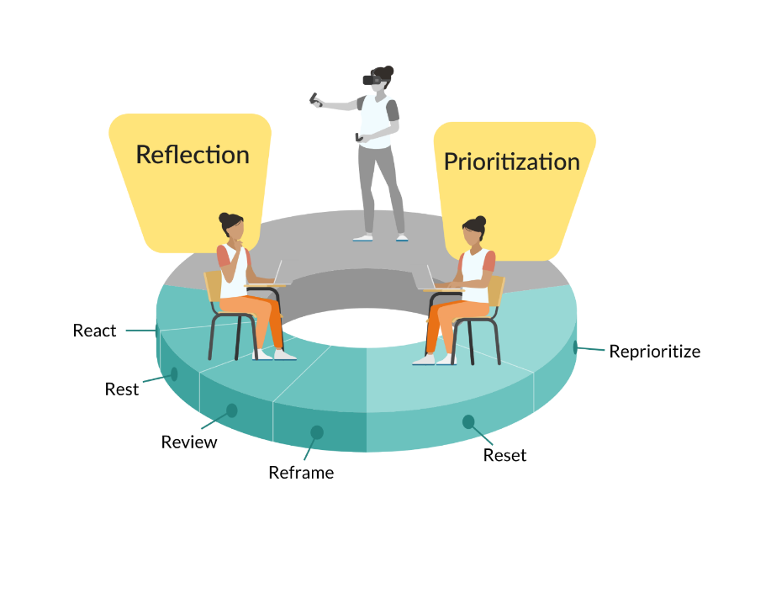
The individual reflection exercises are structured using the six Rs:

React
The react phase represents the immediate emotional state of the learner upon completing the simulation. After completing a realistic simulation experience, it is important to provide room for the emotional response before inquiring about the cognitive considerations (emotion before cognition).

Rest
Rest is important after a cognitively demanding simulation experience in which all senses are active and engaged. A short rest will allow the learner’s brain to revert from focused thinking to diffuse thinking, allowing them to zoom out and analyze their simulation experience (Oakley et al., 2021).

Review
The simulation experience is reviewed using a feedback log, which gives the learner an overview of what key priority actions they completed or did not complete in the simulation.

Reprioritize
Reprioritizing occurs twice in the experience: retrospectively and prospectively. Retrospective reprioritizing happens when learners reflect on how they could have prioritized differently going into the simulation, and prospective reprioritizing occurs during the simulation when the learner ongoingly reprioritizes their plan of care, responding to interruptions and the patients’ development.

Reframe
In the reframe phase, the learner is asked a series of guided reflection questions based on their experience and the actions they took or did not take in the simulation. For example, they could explain their thinking process and prioritization considerations as they received a call from the provider with new information about one of their patients.

Reset
In the two-part unfolding simulation experience, the Reset happens after the learner has finished reflecting on the previous simulation experience. The learner is then given some new information about their patients, as their conditions might have changed. The reset is also a recommended part of the synchronous debriefing, where the instructor guides the learners’ sensemaking process and prepares them for future multi-patient encounters.

Feedback and Evaluation

Understanding Assessment and Scoring
Formative assessment is a means of evaluation that helps faculty determine what learners are learning. Improving teaching and learning requires the use of classroom assessment techniques that can guide course revisions (Billings & Halstead, 2020).

The vrClinicals for Nursing experience provides targeted activities for learners to reflect on and track their in-action thinking and decision-making. For an overview of the activities, see Figure 1. Following each virtual clinical simulation, learners continue with post-VR activities (the six Rs), allowing opportunities for and providing measures and rationales to support improvement over time and/or with practice. The feedback log provided to the learner can guide faculty with a snapshot of how well learners have grasped the learning outcomes targeted by the simulation scenario, but it does not represent a summative assessment of mastery.

The feedback compares the learner's performance in simulation to how well their pre-prioritization and reprioritization match the recommended prioritization. The feedback rationale’s structure follows a three-step cognitive process of assessment/reassessment, decision-making, and prioritization.

The recommended prioritizations in the vrClinicals program is based on factors like the patients’ acuity levels, airway, breathing, and circulation (ABC) concerns, acute symptoms, potential risk, and time sensitivity. It does not represent a summative assessment of mastery. As a means of formative assessment, it provides feedback that assists in remediating a learner's clinical judgment and decision-making ability.

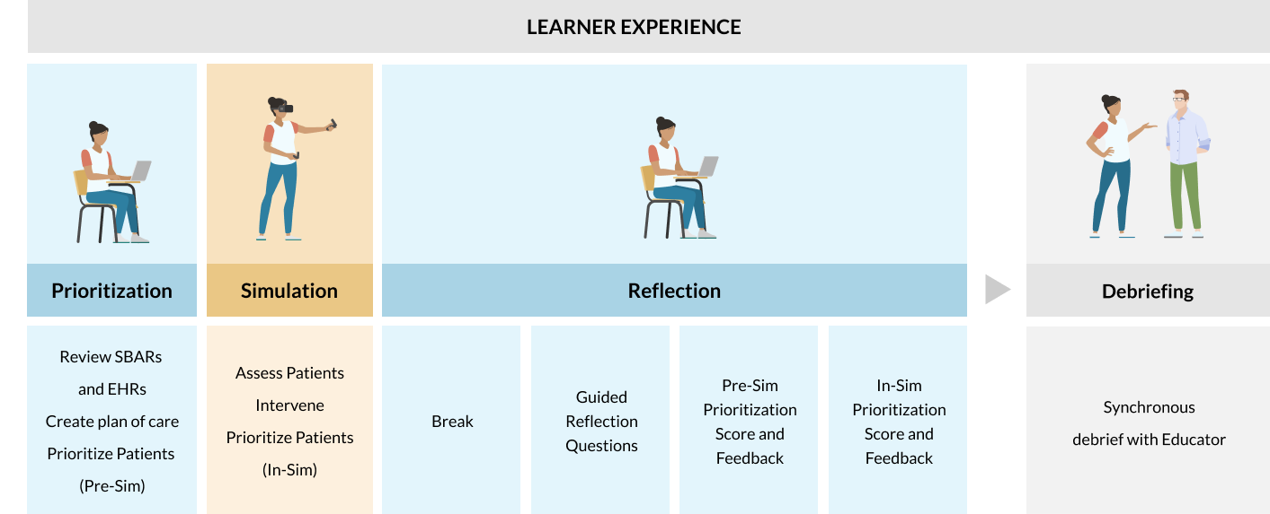
Figure 1 The vrClinicals self-led reflection phase includes guided reflection questions, review of Pre-sim and In-sim scores, and feedback after the simulation(s). In addition, it is recommended to complete the vrClinicals experience with a facilitator-led debriefing session.

Prioritization Reviews: The Principles of Reflection, Feedback, and Scoring

Pre-Simulation Prioritization
The pre-simulation star score is designed to evaluate learners’ ability to prioritize patients based on their needs, as described in the SBAR handoff and the EHR before the simulation starts. This score reflects the learners’ ability to recognize and analyze cues from the SBAR reports and the EHR’s and to prioritize the patients based on the given cues.

To calculate the score, each patient in a scenario is assigned an internal priority score guided by factors such as acuity levels, ABC concerns, potential risks, and time sensitivity (layer 3 and 4 of the CJMM). When the priority of the patients differs from the internal priority score, the star scores go down.

In-Simulation Prioritization
The star score for the in-simulation experience evaluates how well the learners can prioritize the order in which they care for their patients during the simulation. It consists of two main components: a vertical and horizontal scoring algorithm.

The vertical component of the algorithm assesses the correctness of actions performed for each patient and the order in which these actions are executed. It evaluates whether the correct actions are carried out and in the right sequence. The results from this evaluation feed into the second component of the model, the horizontal scoring algorithm, which evaluates whether the learners care for the most acute patient at any time.

Additionally, time is factored into the model. The faster a learner can address a critical patient's issues, the higher their overall score. This encourages learners to address high-priority patients first and rewards them for doing so efficiently. By combining these elements, this educational experience aims to help learners learn how to prioritize patients effectively and efficiently while reinforcing proper procedures and decision-making skills.

Gradebook
In the learner's Gradebook on thePoint, an overall percentage score for the full vrClinicals experience will be presented along with a feedback log including the learner’s planning and reflection entries, together with the learner’s star scores and rationales for pre-simulation prioritization and in-simulation critical actions. The overall percentage score represents an average of the star scores for Pre-Sim and In-Sim activities that the learner will have received as part of the reflection part of vrClinicals.

Synchronous Debriefing
The Healthcare Simulation Standards of Best Practice™ The Debriefing Process provides recommendations on ways to effectively guide learners to reflect on individual or group performance following a simulation experience. The debriefing process may include elements of performance review and analysis through either self-debriefing/reflection or facilitator-led debriefing in the form of a collaborative learning conversation – or both.

The vrClinicals experience is designed to conclude with an instructor-led synchronous debriefing. The scenario-specific debriefing guides (available via thePoint) supports the instructor’s facilitation of debriefing and includes:
- Elements derived from the learning outcomes.
- Exploration of performance gaps using dialogue that promotes reflection, maintains psychological safety, honors confidentiality, and promotes growth.

Teaching Strategies and Use Cases

On-Campus Clinicals
Real-life patient care settings allow for direct supervision and correction of mistakes. However, faculty and learners see the benefits of replicating these experiences in on-campus simulation labs. These labs, also known as “on-campus clinicals,” provide microteaching opportunities for learners to practice critical thinking and clinical reasoning skills, enhancing their clinical judgment. The key is that the experiences can be replicated for all learners with the opportunity for repetitive practice.

Simulating a Whole Day in Clinicals
When using the scenarios to provide an unfolding experience, the learners could have a full day of simulation during which they go through both parts in a single day, replicating a whole day in clinics. When doing that, one option is to start with one pre-brief in the morning, introducing learners to the unfolding concept and that they will be going through 2 simulations, and combine the synchronous debriefing for both parts into one debrief session at the end of the day as shown on Figure 2.

Synchronous debriefing with an instructor is a crucial component of the full vrClinicals experience, and the debriefing guides are structured for both standalone and unfolding experiences.

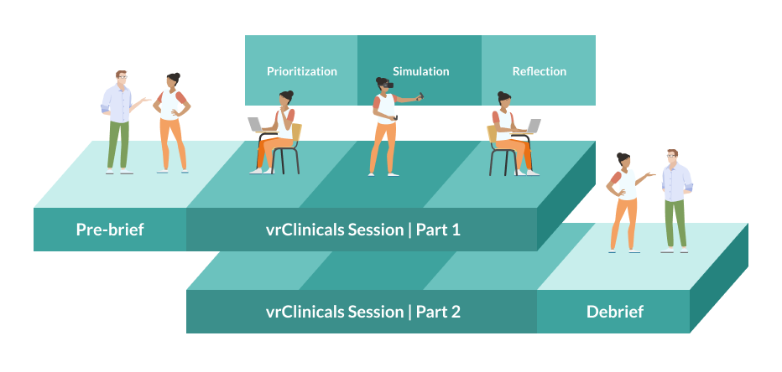
Figure 2 Example of how the 2 parts of the unfolding scenarios can be used together to replicate a whole day in clinics with one initial pre-brief and one combined synchronous debrief at the end of the day.

Makeup Activity
vrClinicals provides a flexible approach for arranging makeup activities that are accessible at any time, streamlining the process by removing the need to coordinate with clinical faculty's schedules or hospital availability.

The immersive virtual environment mirrors the distractions and complexity found in actual clinical settings, offering learners a high-fidelity simulation. This allows for the completion of a full clinical day's worth of experience within a four-hour virtual reality session, ensuring an efficient catch-up on missed clinical time without sacrificing the educational quality.

Remediation
For learners facing challenges with specific concepts or skills, the vrClinicals experience offers focused practice sessions. Its design emphasizes building proficiency through consistent feedback, which is a huge advantage for learners requiring remediation.

Boot Camp Activities
The vrClinicals experience can complement other Boot Camp activities. A structured approach could involve a half-day dedicated to simulation exercises, followed by a session of educational videos and discussions. This format provides a practical application of learned skills, followed by a period of reflection and feedback, which is vital for the learners' learning and development.

Incorporating an immersive vrClinicals simulation into boot camp activities enriches learners' experiences, equipping them with practical skills in a simulated setting that mirrors the complexity of real-life clinical environments.

During the boot camp day programs, learners should be introduced to the vrClinicals environment and the scenarios they will experience. This includes a pre-briefing session where educators are available to guide the learners, setting clear learning outcomes and expectations.

The simulation scenarios challenge learners to manage the care of multiple patients. This training is valuable for teaching learners to prioritize care and manage various responsibilities effectively. In these scenarios, the learners are required to apply their knowledge and make rapid decisions in a dynamic setting. The scenarios are scalable, allowing for an increased patient count to gradually challenge the learners, ensuring they are not overwhelmed.

Following each simulation, learners undertake self-led exercises, which include guided reflection questions and a review of performance scores. This reflective process is crucial for learners to evaluate their performance, recognize areas needing improvement, and solidify their understanding before entering the real-life clinical environment.

Supplementing Clinicals
vrClinicals can ensure that learners get specific experiences by simulating scenarios that they might not encounter in clinical settings. For example, the simulation can include scenarios where learners must perform critical tasks rather than just observe.

To address the concern that learners may not experience high-acuity scenarios, vrClinicals offer simulations with varying levels of patient acuity, including critical care scenarios, allowing all learners to practice high-stakes decision-making. This allows learners to actively participate in patient care within the simulation, thus avoiding the limitations they may sometimes face in real clinical settings.

vrClinicals simulate environments where learners must prioritize care among multiple patients, helping them develop this critical skill that they may not practice enough during clinical rotations due to having only one patient at a time.

The vrClinicals experience empowers learners to take the lead and make decisions, simulating both routine and emergency situations to enhance their confidence and competence in real-world clinical decision-making.

Alternative Teaching Strategies: Utilization in Classroom Teaching
vrClinicals for Nursing provides the opportunity for faculty to replicate a multi-patient clinical experience for each learner, enhancing their proficiency in executing the unique clinical judgment skills associated with caring for multiple patients. As a classroom approach to demonstrating thinking in action, vrClinicals provides opportunities for immediate feedback to strengthen learner thinking.

Small-Group Conversations
Using vrClinicals for Nursing in the classroom can be operationalized by having small groups run 25-45-minute scenarios on a computer using the screen-based app or casting one learner’s VR simulation to a screen with the opportunity for pausing and engaging the small group in conversations as decisions are generated, considered, and then acted upon. This instrumental approach enables robust dialogue and cooperative thinking. Learning is incorporated through thinking, decision-making, and corresponding correct rationale variations.

Classroom Concept Mapping
Group concept mapping can enhance the learner’s vrClinicals scenario experiences by working directly with the clinical concepts and exemplars in the scenario cases. Collaboratively, learners expand concept relationships using a group concept mapping approach. This iterative approach to learning provides active reflection to leverage the thinking-in-action with the associated rationale for actions taken and their impact on patient care and patient outcome.

Resources and References

Resources
- National League for Nursing Simulation Innovation Resource Center (SIRC): https://www.nln.org/sirc-reimagined-courses. In SIRC you will find courses about:
- Foundations: Laying the Groundwork for Teaching with Simulation
- Modalities: Exploring Simulation Features
- Curriculum: Understanding the Curriculum Map for Thoughtful Simulation Integration
- Evaluation and Assessment: Examining Learner, Facilitator, and Program Outcomes
- Prebriefing and Debriefing: Facilitating the Learning Experience
- Facilitator: Exploring Roles in Simulation Delivery
- Interprofessional Education: Leveraging Simulation Strategies for Team Development
- Debriefing
- Verkuyl, M., Hughes, M., Atack, L., McCulloch, T., Lapum, J.L., Romaniuk, D. & St-Amant, O. (2019). Comparison of self-debriefing alone or in combination with group debrief. Journal of Clinical Simulation in Nursing, 37(C), 32-39., https://doi.org/10.1016/j.ecns.2019.08.005
- Verkuyl, M., Lapum, J.L., St-Amant, O., Hughes, M., Romaniuk, D. & McCulloch, T. (2020). Exploring debriefing combinations after a virtual simulation. Journal of Clinical Simulation in Nursing, 40(C), 42. https://doi.org/10.1016/j.ecns.2019.12.002
- Verkuyl, M., St-Amant, O., Hughes, M., Lapum, J.L., & McCulloch, T. (2020). Combining self-debriefing and group debriefing in simulation. Journal of Clinical Simulation in Nursing, 39(C). 41 -44. https://doi.org/10.1016/j.ecns.2019.11.001

References
Diane M. Billings & Judith A. Halstead
PREVIOUS EDITION -ISBN : 9780323554725

Edmondson, A. C., Higgins, M., Singer, S., & Weiner, J. (2016). Understanding psychological safety in
health care and education organizations: a comparative perspective. Research in Human
Development, 13(1), 65-83.

Ericsson, K. A., Krampe, R. T., & Tesch-Römer, C. (1993). The role of deliberate practice in the acquisition of expert performance.
Psychological review, 100(3), 363.

INACSL Standards Committee. (2021). Healthcare Simulation Standards of Best PracticeTM. Clinical Simulation in Nursing, https://doi.org/10.1016/j.ecns.2021.08.018.

Jessee, M. A. (2019). Teaching prioritization: “Who, what, & why?”. Journal of Nursing Education, 58(5), 302-305.
McGaghie, W., lssenberg, S.B., Cohen, E.R., Barsuk, J.H., & Wayne, D.B. (2011). Does simulation-based medical education with deliberate practice yield better results than traditional clinical education? A meta-analytic comparative review of the evidence. Academic Medicine, 86(6): 706-711. doi:10.1097/ACM.Ob013e318217e119.
National League for Nursing. (2023, January). NLN Vision Statement: Integrating Competency-Based Education in the Nursing Curriculum. Vision Series: Transforming Nursing Education Leading to the Call to Reform. https://www.nln.org/docs/default-source/default-document-library/vision-series_integrating-competency-based-education-in-the-nursing-curriculumd6eb0a1e-1f8b-4d60-bc4f-619f5e75b445.pdf?sfvrsn=b37e7538_3
NCSBN (2019). Clinical Judgement Measurement Model: A Framework for Measuring Clinical Judgement and Decision Making. https://www.nclex.com/clinical-judgment-measurement-model.page
Oakley, Barbara, Beth Rogowsky, and Terrence J. Sejnowski. Uncommon Sense Teaching: Practical Insights in Brain Science to Help Students Learn. Penguin, 2021.

Pelletier, K., Brown, M., Brooks, D.C., McCormack, M., Reeves, J., Arbino, N., Bozkurt, A., Crawford, S.,
Czerniewicz, L., Gibson, R., Linder, K., Mason, J., & Mondelli, V. (2021) EDUCAUSE horizon report, teaching and learning edition.
https://library.educause.edu/resources/2021/4/2021-educause-horizon-report-teaching-and-learning-edition

Unger, L., & Sloutsky, V.M. (2022). Ready to Learn: Incidental exposure fosters category learning. Psychological Science), 33(6), 999–1019. https://doi.org/10.1177/09567976211061470

Schon, D. A. (1991). The reflective practitioner. Ashgate Publishing.

